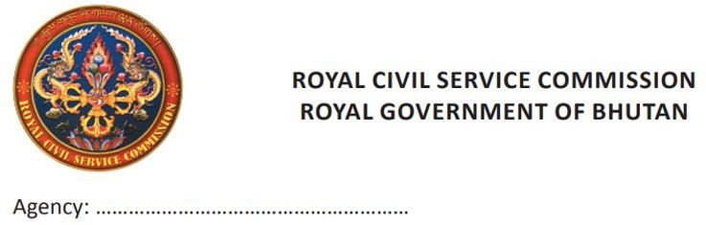
Form I

File No………………………………………

Travel Order

Date:

As per the decision of the HRC/Undersigned vide Note sheet No dated
………………………..………, the following official(s) is/are hereby relieved from his/her office duty as detailed below;
Purpose of Travel:…………………………………………………..…………………………..
Duration: From………………………………...To…………………………………………………………………
Place(s) of Visit:……………………………………………………...…………………………..
Mode of Travel: Pool Vehicle Private Car Bus Taxi Air Train Foot

Funding Source(s): ………………………………………………………………………………

Sl. No. | Name of Official | Designation | Position Level | Remarks
The official (s) is/are instructed to claim the travel entitlements strictly as per this order in accordance to the prevailing travel rules.

Name, Sign & Seal

Head of Budgetary Body/Agency/Controlling Officer
Copy to:
- Controlling Officer of the Individual.
- Individual Concerned.

